Drives and Motors

Abstract
This document introduces the basic concepts and methods used in drives and motors, including the following parts
- Variable-frequency Drives
  - Scalar VFD
  - Vector VFD
- Induction Motors
- Rotating Three Phase Magnetic Field
- Number of poles
- Slip
- Alternative Operations
- Plugging, Braking with DC
- Abnormal conditions
- Speed control
- Regions of operation

1. Variable-frequency Drives (VFD)

1.1 Scalar VFD ^{[1]}
A standard scalar VFD uses PWM pattern designed to maintain a constant varying frequency pattern to the motor under ideal conditions. How the motor reacts to that PWM pattern is very dependent upon the load conditions which the Scalar drive knows nothing about. It only tells the motor what to do. True torque control cannot be realised with a scalar drive because it has no way of knowing what the motor output torque is.

These problems with the scalar VFDs inability to alter its output with changes in the load gets worse as the speed reference goes down, so the "rule of thumb" in determining the need for which technology to use is that scalar drives would work OK at speed ranges between 5:1 (50Hz applications) or 6:1 (60Hz applications). So for applications which need accurate control below 10Hz, scalar VFD may not work properly.

1.2 Vector VFD ^{[1]}
A Vector Drive uses feedback to further modify the PWM pattern to maintain more precise control of the desired operating parameter, be it speed or torque. Using a more powerful and faster microprocessor, it uses the feedback information to calculate the exact vector of voltage and frequency to attain the goal. In a closed loop, it goes on to constantly update that vector to maintain its. Vector drives come in 2 types, Open Loop and Closed Loop, based on the way they get their feedback information.

1.2.1 Closed loop Vector Drive (Slip frequency)
A true Closed Loop Vector Drive uses a shaft encoder on the motor to give positive shaft position indication back to the microprocessor. For torque control, the feedback allows the microprocessor to adjust the pattern so that a constant level of torque can be maintained regardless of speed.
.A true closed Loop Vector Drive can also make an AC motor develop continuous full torque at zero speed, something that previously only DC drives were capable of. That makes them suitable for crane and hoist applications where the motor must produce full torque before the brake is released or else the load begins dropping and it can't be stopped.

1.2.2 Sensorless Vector Drive
For a sensorless vector drive, the feedback loop comes from within the VFD itself instead of an external encoder. For this reason there is a trend to refer to them as "Sensorless Vector" drives. The microprocessor creates a mathematical model of the motor operating parameters and keeps it in memory. As the motor operates, the microprocessor monitors the output current (mainly), compares it to the model and determines from experience what the different current effects mean in terms of the motor performance. Then, the microprocessor executes the necessary error corrections just as the closed Loop Vector Drive does.
The only drawback is that as the motor gets slower, the ability of the microprocessor to detect the subtle changes in magnetics becomes more difficult. At zero speed it is generally accepted that an Open loop Vector Drive is not reliable enough to use on cranes and hoists. For most other applications though it is just fine.
Sensorless vector control bases on feedback current and mathematical determination of motor characteristics and operating conditions, while the closed loop vector control with encoder feedback bases on motor shaft speed and position feedback from an encoder.

1.3 Application

Scalar | Applications do not need high control precision, like fans and pumps.
Closed loop Vector | Used for systems with the highest demands for accuracy
Sensorless Vector | Suitable for the system require less torque control accuracy, such as wire-wound, drawing machines

2. Induction Motors
Induction refers to the inducted current in the rotor; in synchronous motor, there is no induction current but excitation current

2.1 Rotating Three Phase Magnetic Field
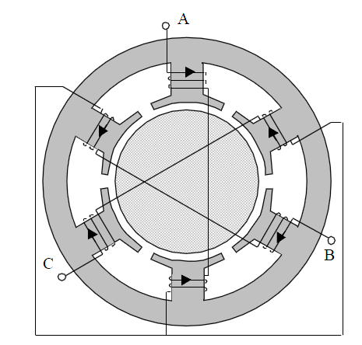

(stator (dark gray) and rotor(light gray))
Note the internal connections, which current flows from A to the opposite position of A with the same direction

2.2 Number of poles ---- synchronous speed
The synchronous speed is given by

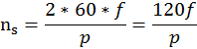

2.3 Slip
The rotor speed is always slightly less than synchronous speed.
A motor only turns at constant speed when its torque is exactly equal to the torque exerted by the mechanical load.
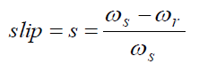

If under no load, the slip is about zero, as the speed of the stator equals to the speed of the rotor

2.4 Alternative Operating Conditions
Slip | Operation Equivalent
s<0 | Generator
0<s<1 | Motor
s>1 | Brake (rotor backward)
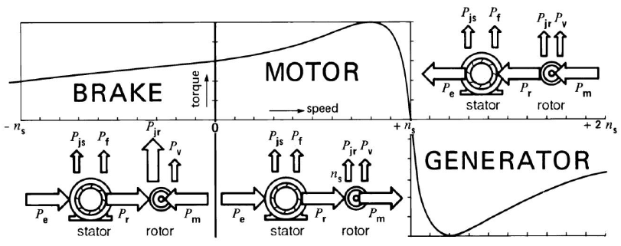

2.5 Plugging, Braking with DC

Plugging
To stop the motor, reverse the motor winding phase connections, so the rotating field turns in the opposite direction to the rotor. This is called plugging.
It does cause considerable heat to be generated in the rotor; up to three times the machine kinetic energy is dissipated because of the reversely-rotating field

Braking with DC
Another approach is to pass DC through the stator. This produces a DC magnetic field (non-rotating) which induces rotor currents only while the rotor is turning. The heat loss in the rotor for this operation is only equal to the kinetic energy stored in the rotor.

2.6 Abnormal conditions

Line voltage change
In effect, the torque at any speed is proportional to the square of the applied voltage. A line voltage drop is often produced during start-up, due to the heavy starting current drawn from the line, and the starting torque may be much less than its rated value.
When the motor is running, high line voltage cause iron losses, the magnetizing current and temperature to increase

Frequency variation
Frequency changes motor speeding proportionally.

2.7 Speed Control

Varying voltage
Speed control by variable voltage is only attractive for selected speed control applications. The useful speed range for a constant load torque is relatively small, and the maximum torque available at reduced supply voltages drops rapidly.
It is used for its simplicity.

Varying slip
The external rotor resistance increases causing the slip to increase and n to decrease.
A more practical approach is to rectify the rotor winding voltages, and use a DC-DC buck converter to control the energy dumped into an external load resistance

Varying Frequency
As the supply frequency varies, the reactances of the motor inductances will change proportionally, causing the magnetic flux inside the machine to also vary which is undesirable.
To avoid this problem, the voltage magnitude of the variable frequency supply should be controlled by
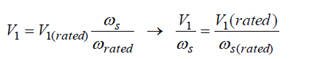

This characteristic can only be maintained up to rated supply frequency because the input voltage magnitude cannot exceed V₁(rated) due to motor insulation or supply restrictions. Above rated frequency, the motor moves to field weakening mode with reduced flux.

Open Loop and Closed Loop
Open loop control can achieve reasonable performance because of the steep torque-speed characteristic of the induction motor at small values of slip, although closed loop control is to be preferred for higher performance applications as it is not susceptible to DC changes

2.8 Regions of operations
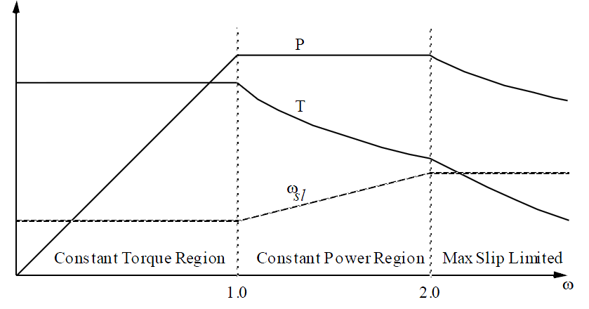

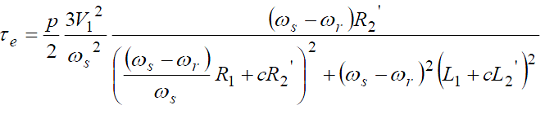

Constant torque
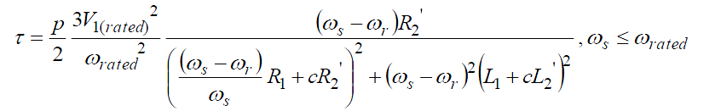

The rotor speed increases with increasing supply frequency, while the torque is constant; thus, the power increases.

Constant power
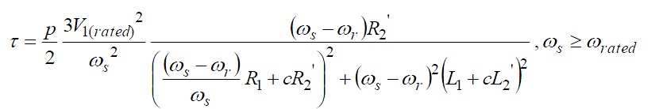

The rotor speed increases with increasing supply frequency, while the power is constant; thus, the torque decreases.

Reference
[1] http://www.eng-tips.com/faqs.cfm?fid=1062 Accessed on 22-Apr, 2013

